# Assignment Number: 1.3

# Problem Statement:

To execute two m files named calc_area and sin_x in command window and then use the workspace browser to determine which variables are defined in the current workspace.

# Inputs :

The required m files calc_area and sin_x

# Outputs:

Execution of the m files in command window

# Pseudocode:

* Create the two m files.
* Execute the two files in command window
* Use the workspace browser to find the variables
* Modify the content
* Again excute the m files
* There would be some change in the results from the default one.
* Stop

# Program 1 :calc_area.m

%script file:calc_area

%objective:To find area of circle

%Record of revision

% date programmer description of change

% ==== ========== =====================

% 12/08/15 satyabrat sahoo original code

%

%Define variables

%r=radius of circle

%prompt the user for the input variables

r = input('radius of circle = ');

%calculation

area=pi*r^2;

%write the result

disp('area = ');

disp(area)

# Program 2:sin_x

clc;clear all;close all;

x=(0:0.1:15);

y=sin(x);

plot(x,y)

# Test Results 1:

radius of circle = 5

area = 78.5

After changing the variable r from 5 to 7,we get

Area=153.86

# Test Result 2:

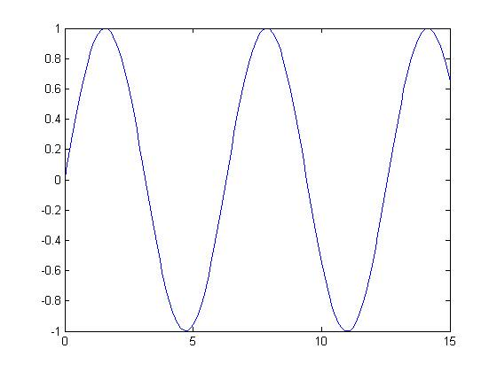

# Discussion

These two files are executed in the command window and the results are in same as in the editor window

The variables that has been observed in the workspace window are r(radius) for the first program and x (for the sin_x program) which are the defined variables

The variables x can be observed in the array editor and the values are x=



Then we Change one or two of the element if the variables x

Then we Rewrite the new x



Then we Plot(x,y) in the command window which is the command window

The new plot is different from the initial one since we changed some of the values..

Here paste the changed graph

